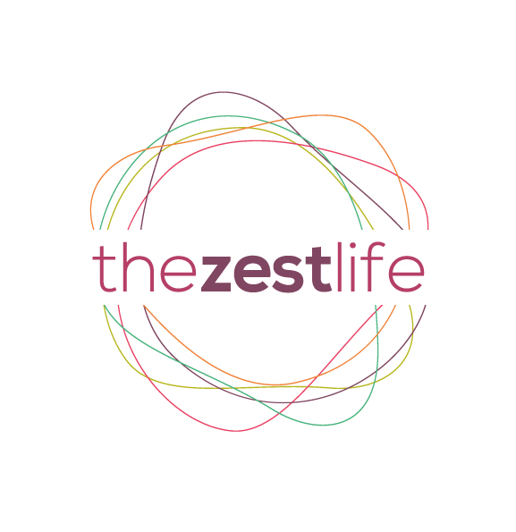 Information we need from you:
The Zest Life Retreats | Booking Form
Thank you for your enquiry about our retreats. Please complete the booking form below and email to info@thezestlife.co.uk or print and post to Laura Bell, 3 Brookland Terrace, Deganwy, Conwy, LL31 9UN

Name:
Email address:
Tel. #: Home: Mobile:
Address:
D/O/B: Age:
Emergency contact name: Tel. #:
Dates and theme of weekend booking:
How did you hear about us? Website FB Referral Flyer Yoga Show Other
How long have you been practicing Yoga? In brief tell us about your practice.

Any medical concerns / injuries?
Any food allergies / intolerances?
Any other information we should know about?

Accommodation options:
Please highlight your choice of retreat & accommodation:–
2 day retreats | Twin room  shared | Single room  Single occupancy | Double room  shared | Double room  Single occupancy
Spring Sensation | 295 | 345 | 295 | 445
Wild Swimming | 345 | 395 | 345 | 495
Autumn Recharge | 295 | 345 | 295 | 445

3 day retreats | Twin Room shared | Single room  single occupancy | Double room  shared | Double room  Single occupancy
Spring Sensation | 345 | 405 | 345 | 505
Autumn Recharge | 345 | 405 | 345 | 505
Winter Warmer | 345 | 405 | 345 | 505
Fitness | 395 | 455 | 395 | 555
Hiking Snowdon | 395 | 455 | 395 | 555
Wild Swimming | 395 | 455 | 395 | 555
Mountain Biking | 395 | 455 | 395 | 555
Mindfulness | 435 | 495 | 435 | 595
Life Coaching | 435 | 495 | 435 | 595
Nutrition | 435 | 495 | 435 | 595
Payment:
A non-refundable £75 deposit is payable on booking to reserve your place.
Remainder of balance is due 28 days prior to start of the weekend.
Please specify your payment option: Cheque BACS

BACS Acct No. 22869670 Sort Code. 54 -41-06 Ref. Your name

Please go to http://thezestlife.co.uk/terms-and-conditions/ for our terms & conditions.

Signed: Date:

All done!
Thank you for your custom, we look forward to sharing our zest life with you very soon.

